**Detailed dataset information sheet**

|  |  |
| --- | --- |
| **Information Objective** | Roads and Transport Hubs |
| **Data Products** | Coles Distribution Centres |
| **Information Source / Model Product** | [Coles corporate website](https://www.supplierportal.coles.com.au/csp/wps/wcm/connect/1a58c1004dc735daae99ffa55e9e2fc0/FP+DC+Contacts.pdf?MOD=AJPERES&CACHEID=1a58c1004dc735daae99ffa55e9e2fc0), Google Maps, Earth and Search Engine |
| **Product Completion Progress** | Bunnings retail sites complete  Bunnings Trade/distribution sites in progress  Coles general distribution centres complete  Coles product specific distribution centres e.g. fresh produce in progress  Woolworths Distribution Centres complete |
| **Dataset / Metadata Document** | ColesDistributionCentresUniqueGPS.shp  Coles – Australian Distribution Centres Metadata.pdf |
| **Dataset Use** | Surveillance Strategy and Design, Pathway risk analysis |

**Background**

A national point feature spatial dataset layer identifying major distribution centres for Bunnings, Coles and Woolworths is currently being developed utilising publicly available information from Google Earth, Google Maps and associated search engine.

The initial facilities for these corporate entities were identified from their corporate websites. For Woolworths, an excel spreadsheet containing all their locations was procured from one of their contact page.

**Initial Dataset Procurement Process**

The dataset has been derived by a number of manual processes:

* The list of Coles distribution centres for Australia was sourced from their corporate website and manually geo-coded into the Australia – Coles Distribution Centres.xls excel spreadsheet by extracting GPS coordinate values using Google Maps (Figure 1)
* In the course of locating and visually confirming each site, online documents containing information about product specific distribution centre locations were identified
* These product specific distribution centres are categorised in groups such as “Fresh Produce”
* Some sites were found to be mapped in groups against the same address
* Sites were filtered for Unique GPS coordinates and the remaining sites were imported into ESRI’s ArcMap and processed into a feature layer

Figure 1. Excel spreadsheet of Coles’ Distribution Centres

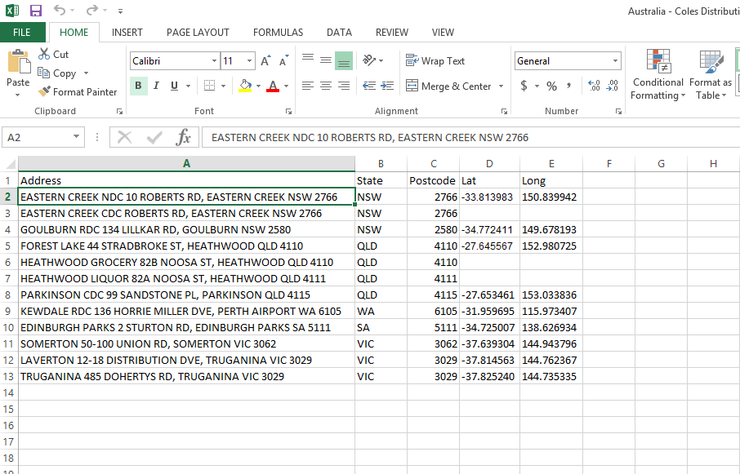

**In progress Dataset Procurement Processes**

Following this initial data compilation it was identified that Coles had product specific centres such as fresh produce which did not show up in their initial general distribution list.

Therefore a similar approach can be adopted as per the points outlined in the initial data procurement section.

**Limitations**

* None considered at this stage of the procurement

**Quality Check**

* The corporation could be contacted to confirm operational status of these sites and for advice on new locations under construction or to be constructed

Table 1. Summary of the datasets and their completion status to date

|  |  |  |  |  |
| --- | --- | --- | --- | --- |
|  | **Initial feature Count** | **Additional features detected using online sources** | **Estimated number of distribution centre features to be captured** | **Estimated total feature count of completed dataset** |
| **Coles Australia** | **9** | **6** | **~25** | **~40** |

Discussion and Future Work

Future work may include quality assurance checks to confirm ownership details and ensure facilities identified are still operating.

Calculation of useful feature attributes such as:

* Proximity in kilometres to major freight hubs, AA ports of entry and community gardens

Project Resources Estimates and Uses

An estimate of the timeframes and data procurement requirements required to complete this dataset is summarised in Table 2.

The end result will be a dataset product which is of a High to Authoritative quality and can be referenced as a point of truth data source for input into projects such as surveillance strategy and design.

This dataset will provide accurate and useful information such as:

* Coles andmajor distribution centres
* Ownership and Contact information
* Area sizes

And will assist in:

* Serving as an input in estimating labour and capital resources for conducting surveys for pests such as those in the National Priority Plant Pests (NPPP) target groups, e.g. number of field officers required to inspect a given quantity of plant seedlings over a specified amount of time
* Mapping requirements for national/state emergency response programs that are deployed when these pest incursions occur
* Providing a feed-in data layer alongside the national road network for determining distribution pathways and the risk levels of these pathways

Table 2. Comparison of process methods and output dataset quality expectations

|  |  |  |  |  |
| --- | --- | --- | --- | --- |
| **Process** | **Requires Industry Assistance** | **Requires State Government Assistance** | **Estimated time to complete** | **Expected Dataset Quality Level** |
| Coles | Possibly – for quality checking operational status and ownership details of identified facilities | No | ~ 2 weeks | High to Authoritative |